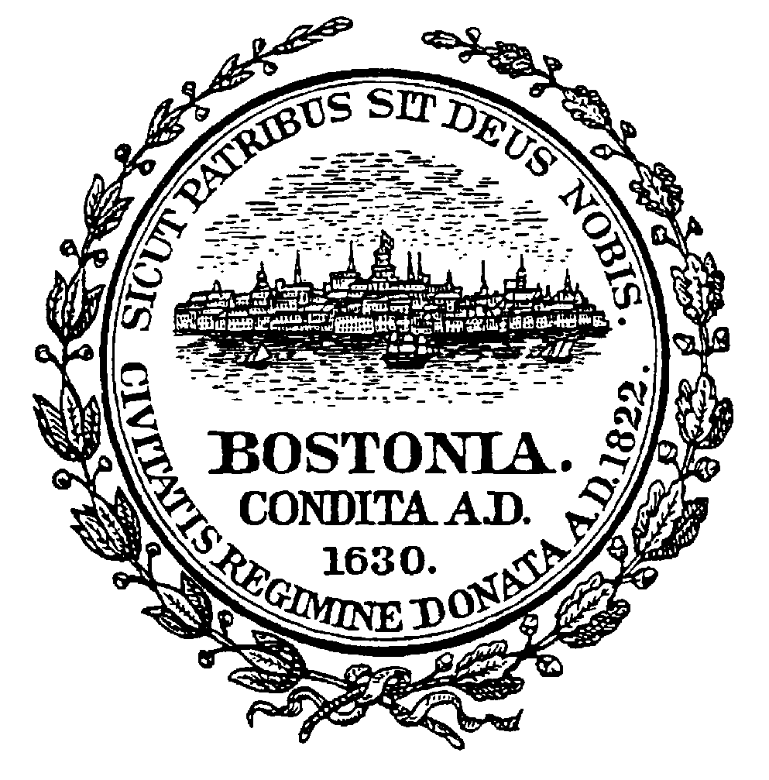

ADVERTISEMENT

CITY OF BOSTON
MAYOR’S OFFICE OF HOUSING

REQUEST FOR PROPOSALS
LAND

HOUSING WITH PUBLIC ASSETS: WEST END LIBRARY

The City of Boston, acting by and through its Public Facilities Commission by the Director of the Mayor’s Office of Housing, Neighborhood Housing Development Division, sells tax foreclosed or surplus municipal property to buyers who agree to invest in the rehabilitation of the property. Residential, commercial, and institutional buildings and land are included in this program. The Housing With Public Assets: West End Library Request for Proposals makes land available specifically for the development of housing co-located with a new West End Library branch.

This Request for Proposals (RFP) is to solicit proposals from qualified nonprofit organizations or other entities for the development of the parcel as affordable rental housing co-located with a new West End Library branch. The property is being offered As-Is and the successful applicant will enter into a 99-year ground lease with the City of Boston.

The Property:
151 Cambridge Street (Ward 3, Assessor’s Parcel 0300656000), Boston, MA, totaling approximately 22,210 square feet.

Property Viewings:
It is strongly recommended that prospective developers avail themselves of the opportunity to inspect the site by visiting it so that they may prepare their proposals accordingly.

The RFP package will be available on April 3, 2023, and can be downloaded by registering at https://boston.gov/dnd/rfps. If you are unable to access it, please contact the Development Officer. Due to the ongoing health precautions that the City has taken due to COVID-19, completed RFP responses must be submitted electronically by June 15, 2023, no later than 4:00 P.M. (EST). Late proposals will not be accepted. Please go to https://boston.gov/dnd/rfps for detailed instructions on how to submit RFP responses.

The Mayor’s Office of Housing (MOH) will host a pre-applicant information session following the release of the RFP. Interested Applicants will be provided with an overview of the application and development process. The pre-applicant conference will be held on April 28, 2023, at 11:00 A.M. via Zoom. To participate, pre-registration is required using the following link: https://bit.ly/WestEndApplicantConference

For more information about this RFP contact Joe Backer, Senior Development Officer, at
(617) 635-0226 or joseph.backer@boston.gov.

Sheila A. Dillon
Chief and Director
Mayor’s Office of Housing

